**Algorithm explanation**

First, I use R3 to store the front pointer of the queue and use R4 to store the tail pointer of the queue. Whenever a character is input, I judge whether it is “ENTER” or not. If it is, jump to OUTPUT section and display the character needed to be output. If not, I match it with the four operator. If it is a pop operation, I pop an element(if the queue is empty, pop a _ ) and store it into a specific memory location. If it is a push operation, I continue to input a character and push it into the queue in right or left side. In the OUTPUT section, I use trap instruction to print the character which is needed to be printed.

**Essential parts of your code with sufficient comments**

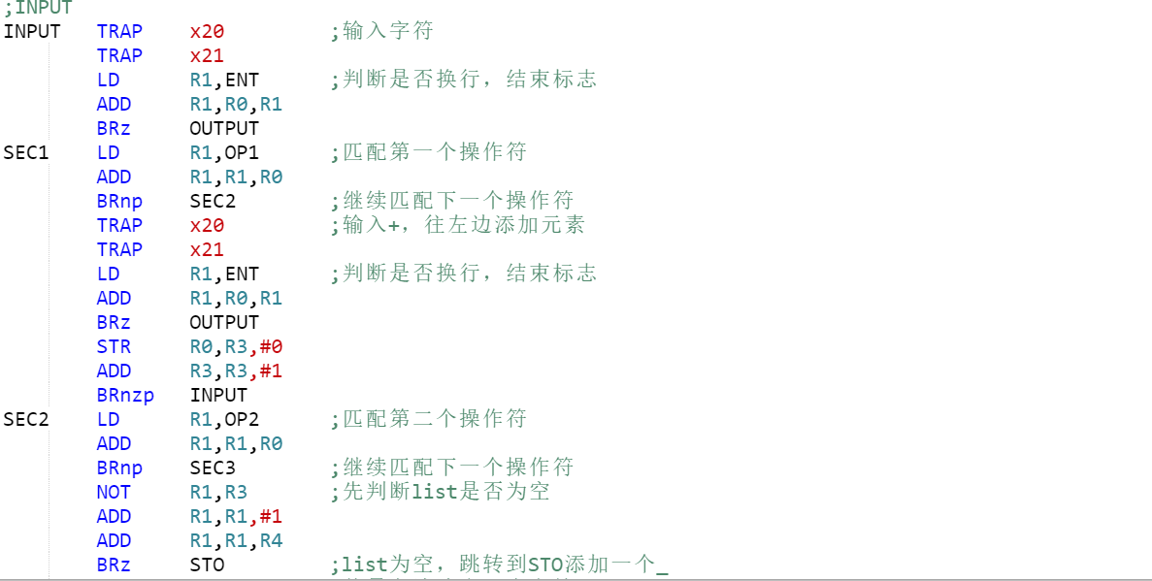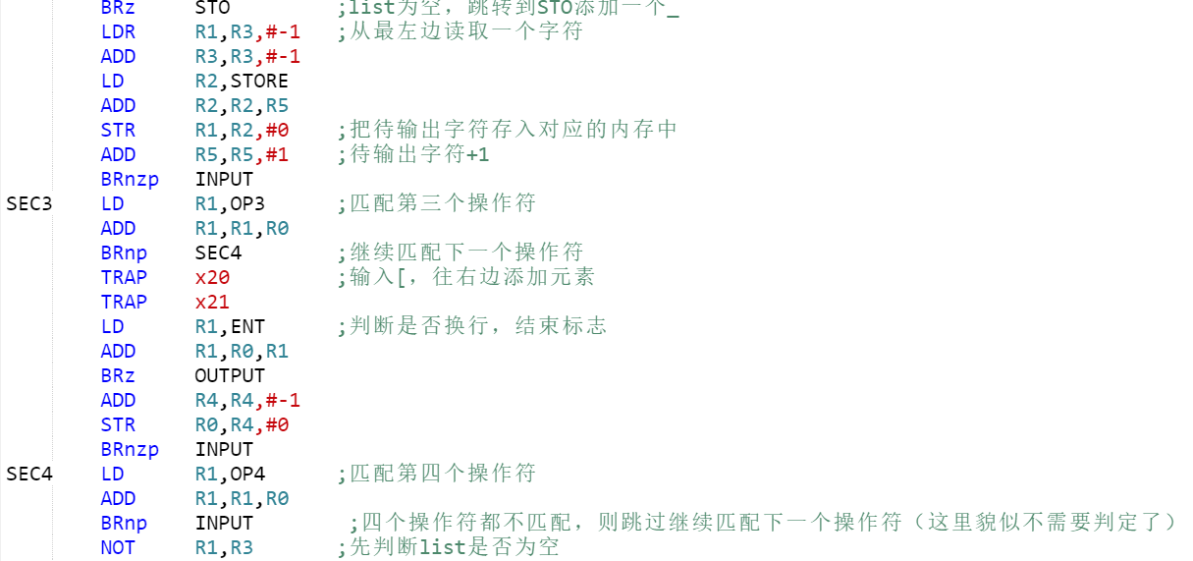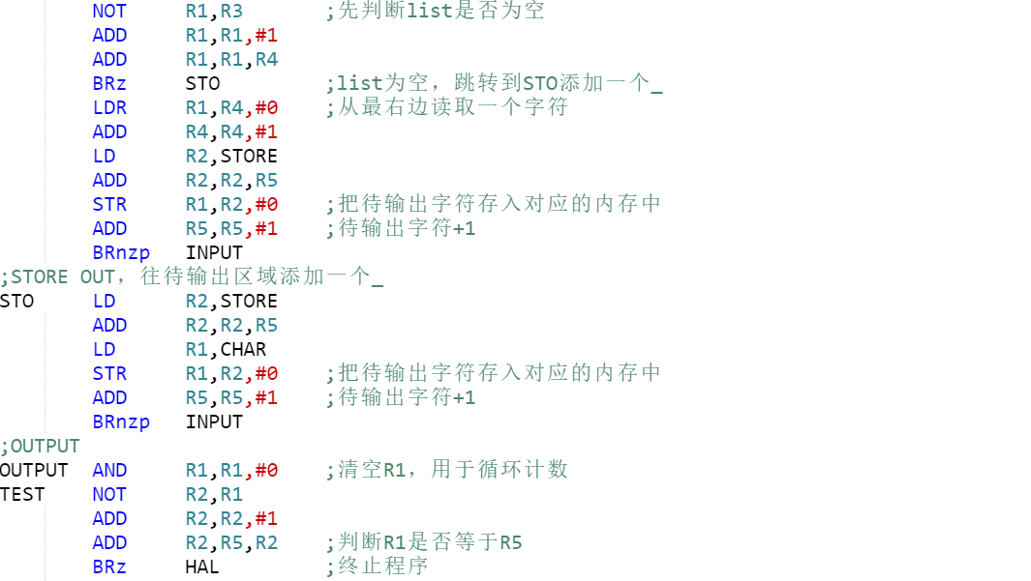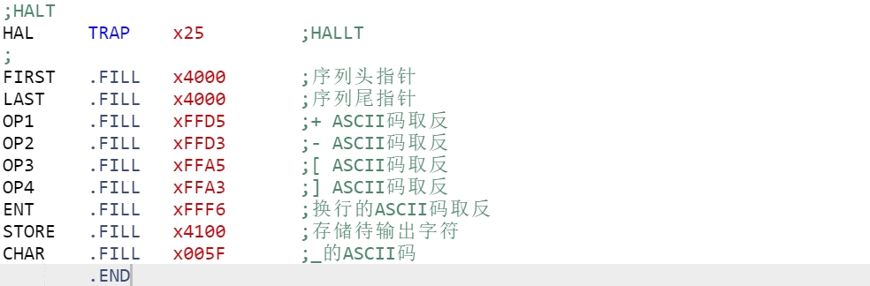

**Questions TA asked you and your answer in Check**

**TA:**What is your approach to this program?

**ME:**First, I set two pointer(front and tail) to the queue which is used to locate the element in the queue. Whenever user inputs a character, check if is “ENTER”. If it is, jump to OUTPUT section and display the result. If not, match it with the four operators and execute according works. If it is in pop operation, pop an element from the queue(if front pointer = tail pointer, pop a _) and store it into a specific area in memory(output area). If it is in push operation, continue to input a character and store it into the queue in right or left side. In the output section, I display all the character stored in the output area.